
CSA15 Cloud Computing and Big Data Analytics
CO1 AT2 - Digital Concept Map and Service Model Matrix
Individual Student Submission Template

Student and Faculty Details
Student Name | M Deepika | Register Number | 192311027
Class / Section | CSE | Slot | C
Course Code | CSA1512 | Course Title | Cloud Computing And Big Data Analytics
Capstone Title | Cloud-Based Medicine Inventory Management System
Submission Date | 13-07-2026
Faculty Name | Dr.Rajesh Babu C | Employee ID
Department

Assessment Brief
Course Outcome | CO1 - Explain the evolution, architecture, characteristics, service models, and emerging paradigms of cloud computing.
Assessment Type | Individual concept mapping, service-model responsibility analysis, and capstone-cloud interpretation.
Assessment Focus | Each map must show key nodes, link labels, relationship meaning, and a logical hierarchy. The response must connect cloud fundamentals to the student's own perception of the capstone title.
Submission Mode | Editable DOCX + exported diagram evidence + GitHub repository link submitted in Google Classroom.
Permitted Tools | draw.io / diagrams.net, Lucidchart, Miro, Canva, PowerPoint, Google Drawings, or equivalent diagramming tool.
Individual Rule | Every student must submit their own concept map, matrix, capstone-cloud mapping, and reflection. The capstone title may be shared by a team, but the assessment answer must not be common.
Total Marks | 100 marks

Code of Conduct and Student Assurance
Academic Integrity Statement
This assessment must be completed individually. Students may discuss the capstone domain with their team, but the concept map, service model matrix, explanations, GitHub evidence, and reflection submitted here must be individually prepared.
Student Assurance | I confirm that this submission represents my own understanding of CO1 concepts and my individual interpretation of the selected capstone title.
Tool Use | I have used digital tools only for diagram preparation, organization, and presentation. I have not copied another student's diagram, matrix, or explanation.
Evidence | I have uploaded the required files to my GitHub repository and submitted the repository link / evidence link through Google Classroom.
Student Signature | M Deepika
Date | 13-07-2026

Procedure for Preparing the Digital Concept Map
Use the following procedure to prepare the diagram and upload evidence. Students who already know another diagramming tool may use it, but the exported evidence and source file must still be submitted.
- Open https://app.diagrams.net/ or the desktop version of draw.io / diagrams.net.
- Choose Device, Google Drive, or OneDrive as the save location according to availability.
- Create a blank diagram and name the file as CSA15_CO1_AT2_RegisterNumber_Concept_Map.drawio.
- Place the capstone title at the center or as a clearly visible anchor node.
- Add major cloud nodes: cloud definition, cloud evolution, cloud architecture, service models, deployment models, virtualization, web services, SOAP, REST, APIs, elasticity, scalability, resource pooling, measured service, and emerging paradigms.
- Connect nodes with labeled arrows such as uses, depends on, enables, scales through, communicates through, belongs to, supports, provides, consumes, or controls.
- Use colors meaningfully: one color for service models, one for cloud characteristics, one for API/web-service concepts, and one for capstone-specific elements.
- Export the final diagram as PNG or PDF. Keep the editable .drawio source file also.
- Paste the exported diagram image or screenshot in this DOCX under Task 1.
- Upload the DOCX, exported PNG/PDF, and .drawio file to GitHub, then submit the GitHub link in Google Classroom.

GitHub Submission Procedure
Step | Required Action | Expected Evidence
1 | Create or use your individual GitHub account. | GitHub profile link.
2 | Create a repository named CSA15-CO-Assessments-RegisterNumber or use the repository instructed by faculty. | Repository URL.
3 | Create a folder named CO1_AT2 inside the repository. | Folder visible in repository.
4 | Upload this completed DOCX, exported diagram PNG/PDF, and editable .drawio source file. | At least three evidence files uploaded.
5 | Add a short README.md explaining the capstone title and files submitted. | README visible in the AT2 folder.
6 | Submit the GitHub folder link in Google Classroom. | GCR submission with repository/folder link.

Assessment Questions and Student Response Sections
Important
The capstone project may be developed by a team, but every response below must be written from the individual student's own perspective. Do not submit a common team answer.

Task 1 - Digital Cloud Concept Map
Create one integrated digital concept map for CO1. The map must show key nodes, link labels, relationship meaning, and a logical hierarchy. It must also connect the concepts to your selected capstone title from your individual perspective.
Mandatory Concept Group | Minimum Concepts / Nodes to Include
Cloud Fundamentals | Definition, characteristics, benefits, limitations, on-demand access, measured service.
Cloud Evolution and Drivers | Hardware evolution, internet software evolution, distributed systems, cost economics, mobility, remote access, big data growth.
Architecture and Deployment | Front-end, back-end, network layer, data center, management software, public/private/hybrid/community cloud.
Service Models and Responsibility | IaaS, PaaS, SaaS, XaaS, provider responsibility, user responsibility, shared responsibility.
Virtualization and Web/API Layer | Virtual machine, hypervisor, abstraction, resource pooling, multi-tenancy, web services, SOAP, REST, API request/response.
Capstone Connection | Your capstone users, app/module, cloud backend, database/storage, dashboard/analytics, scalability and elasticity idea.
Paste exported concept map image / screenshot here. Resize neatly within this white space.

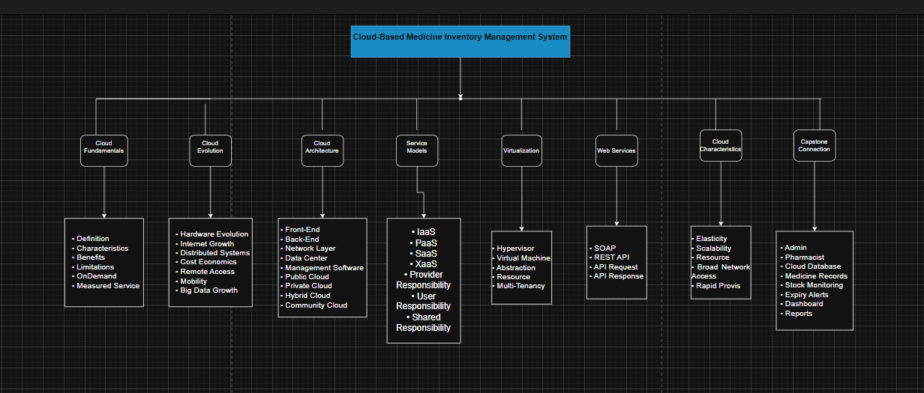

Brief explanation of your concept map: explain the most important nodes, link labels, hierarchy, and capstone connection.
The concept map illustrates the Cloud-Based Medicine Inventory Management System and explains how cloud computing concepts are used in the project. The system is based on cloud fundamentals such as on-demand access, measured service, benefits, and characteristics, which provide easy and reliable access to medicine inventory from anywhere. It also shows the evolution of cloud computing, including hardware development, internet growth, distributed systems, and remote access.
The cloud architecture consists of the front-end, back-end, network layer, data center, and different deployment models such as public, private, hybrid, and community cloud. The project uses service models like IaaS, PaaS, SaaS, and XaaS to support infrastructure, application development, software delivery, and cloud services. Virtualization enables efficient resource utilization through virtual machines and hypervisors, while web services such as SOAP and REST APIs allow communication between the application and the cloud database.
The capstone connection shows how administrators and pharmacists can manage medicine records, monitor stock levels, track expiry dates, and generate reports. Cloud characteristics such as scalability, elasticity, resource pooling, and broad network access ensure that the system can efficiently support multiple hospitals and pharmacies with secure and real-time access to data.

Task 2 - Service Model Matrix
Complete the matrices by making technical decisions for your capstone project. Select only the rows that are relevant to your capstone design. If a row is not used, write a short technical reason instead of leaving it blank.
Your answer should show how responsibility shifts between cloud provider and student development team, and how the chosen services support the capstone workflow, API design, storage, security, scalability, and evidence submission.

Task 2A - Service Model Responsibility Matrix
Service Model | Capstone Role / Module | Provider Responsibility | Student Responsibility | Evidence to Submit
IaaS | Virtual Servers for Application | Provides virtual machines, storage, and networking | Configure server and deploy application | Server configuration screenshot
PaaS | Application Development Platform | Provides runtime environment and development tools | Develop, test, and deploy the application | Application deployment screenshot
SaaS | Medicine Inventory Application | Provides software access through the cloud | Manage medicine records and users | Application interface screenshot
XaaS / Specialized Service | Database and Notification Services | Provides database, cloud storage, and alert services | Configure database and notification settings | Database and alert configuration screenshot

Task 2B - Capstone Cloud Service Decision Matrix
Cloud Layer / Function | Selected Tool or Service | Data / Resource Handled | API or Integration Path | Security / Scaling Note
Client access and UI | Web Browser | User Login and Dashboard | HTTPS | Secure Login
API / backend logic | Node.js + Express | Business Logic | REST API | JWT Authentication
Authentication and identity | Firebase Authentication | User Credentials | Firebase API | Role-Based Access
Database / structured records | MongoDB Atlas | Medicine Details, Stock, Expiry Dates | MongoDB API | Automatic Backup
File / object storage | Cloud Storage | Medicine Reports | Storage API | Encrypted Storage
Monitoring / logs / usage metrics | Cloud Monitoring | Application Logs | Monitoring API | Real-Time Monitoring
Analytics / reporting output | Dashboard | Inventory Reports | REST API | Scalable Reporting
Technical justification: Explain why the selected cloud service pattern fits your capstone project's users, data, API flow, scalability, and security needs.
The selected cloud services are suitable for the Cloud-Based Medicine Inventory Management System because they provide secure, scalable, and reliable management of medicine inventory data. The web interface enables administrators and pharmacists to access the system through a browser. Node.js and Express are used to process business logic and communicate with the database using REST APIs. Firebase Authentication ensures secure user login with role-based access control. MongoDB Atlas stores medicine records, stock details, and expiry information securely in the cloud. Cloud storage is used to save reports and backup files. Monitoring services help track application performance and detect issues in real time. The cloud-based architecture supports scalability, allowing multiple hospitals and pharmacies to use the system simultaneously while maintaining data security and availability.

Task 3 - Capstone Cloud Flow Mapping
Study the sample architecture-flow template below. Redraw it in draw.io / diagrams.net using your own capstone architecture. Replace every generic label with your actual user role, screen, API endpoint, backend logic, cloud storage, analytics output, security control, and scalability or elasticity decision.
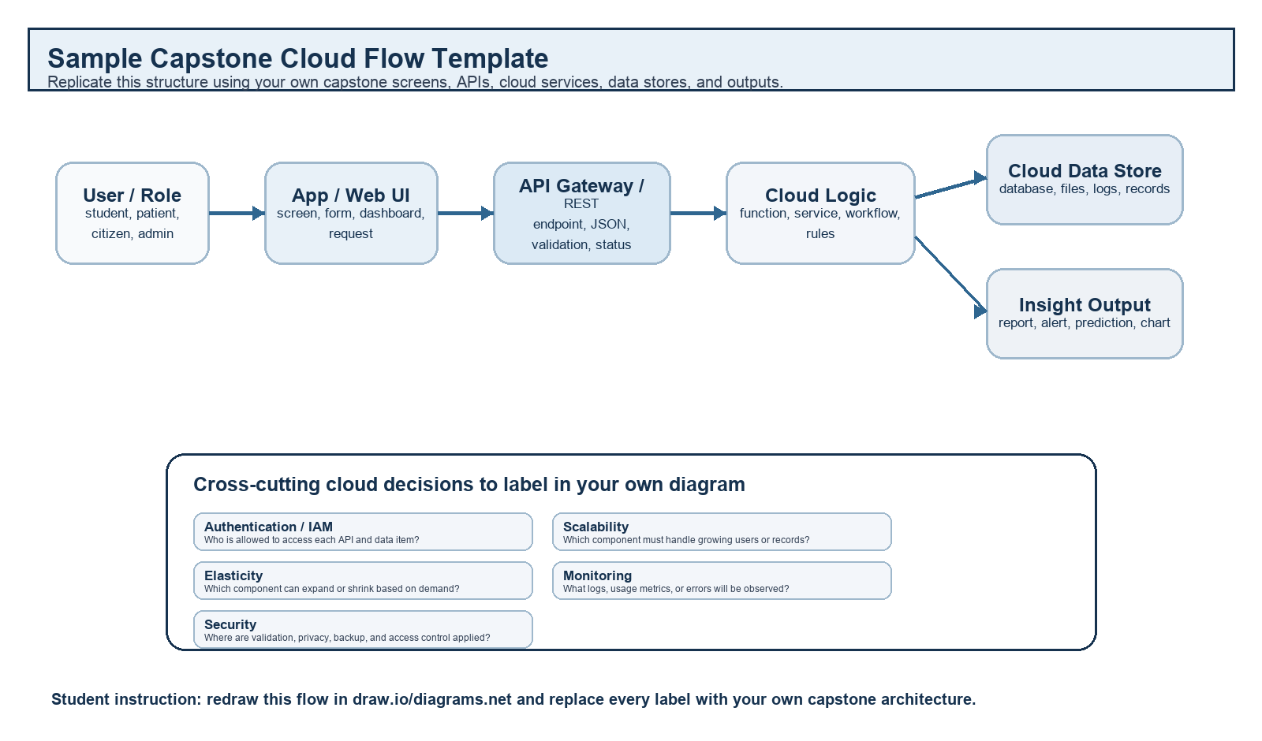
Student Drawing Requirement
Do not copy the sample as it is. Use it as a layout model, then create your own capstone-specific flow diagram with meaningful labels, arrows, data movement, API names, and cloud service choices.
Flow Component | Student Entry
User role and action | Admin / Pharmacist logs into the system and manages medicine inventory.
Frontend / app screen | Medicine Inventory Dashboard
API endpoint and method | POST /login  GET /medicines  POST /addMedicine  PUT /updateStock  DELETE /deleteMedicine
Backend processing rule | The backend validates user credentials, processes medicine inventory requests, updates the database, and generates reports.
Cloud database / storage operation | Medicine records, stock details, expiry dates, supplier details, and reports are stored securely in MongoDB Atlas.
Response, alert, report, or dashboard output | The system displays updated medicine stock, low-stock alerts, expiry alerts, and inventory reports on the dashboard.
Security, scalability, and elasticity labels added in diagram | Security – User Authentication & HTTPS  Scalability – Supports Multiple Hospitals  Elasticity – Automatically Handles Increased User Traffic
Paste your redrawn capstone cloud-flow diagram here.
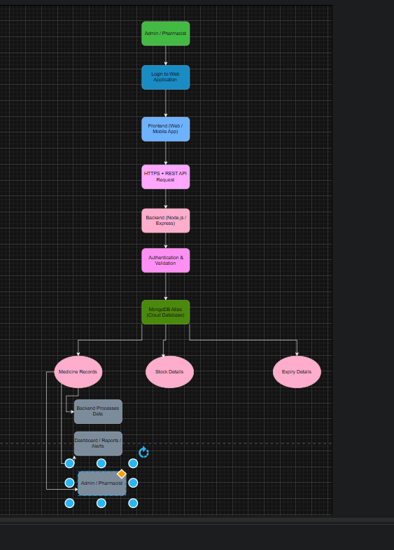

Brief explanation: explain one complete request-response path from user action to cloud response.
The cloud flow diagram shows how the Cloud-Based Medicine Inventory Management System works. The administrator or pharmacist logs into the application through the frontend. The request is sent to the backend using REST APIs over HTTPS. The backend authenticates the user, processes the request, and communicates with the MongoDB Atlas cloud database. The database stores medicine records, stock information, and expiry details. After processing, the system sends the updated information back to the dashboard, where users can view reports, stock availability, and expiry alerts. Security is maintained through authentication and HTTPS, while scalability and elasticity allow the application to support multiple users and healthcare facilities efficiently.

Task 4 - Individual Reflection
Answer the following from your own perspective. Avoid team-common wording.
- What is the strongest cloud concept represented in your capstone project?
The strongest cloud concept represented in my capstone project is cloud-based data storage and on-demand access. It allows administrators and pharmacists to access medicine inventory information securely from anywhere in real time. Cloud technology ensures that the data is always available, reliable, and easy to manage.
- Where will elasticity or scalability become important in your capstone product?
Elasticity and scalability become important when multiple hospitals, pharmacies, and users access the system simultaneously. The cloud can automatically allocate additional resources during high demand and reduce resources when demand decreases, ensuring smooth performance without interruptions.
- Which API or web-service idea is most relevant to your project and why?
The REST API is the most relevant web service for my project because it enables secure communication between the frontend application, backend server, and cloud database. It allows users to add, update, search, and manage medicine records efficiently using HTTP requests.
- What did you personally understand better after preparing this concept map and matrix?
After preparing the concept map and service model matrix, I gained a better understanding of cloud computing concepts such as cloud architecture, service models, deployment models, virtualization, web services, scalability, and security. I also understood how these concepts are applied in developing a cloud-based medicine inventory management system.

Evaluation Rubric - 100 Marks
Criteria | Marks | Expected Standard
Concept identification | 20 | Major CO1 concepts are accurately identified: cloud fundamentals, characteristics, evolution, service models, deployment models, virtualization, web services, SOAP/REST, APIs, elasticity, and scalability.
Relationship mapping | 20 | Links between concepts are accurate, meaningful, and labeled. The map should explain how concepts depend on, enable, consume, provide, scale, or control one another.
Hierarchy and organization | 15 | Concepts are arranged in a logical hierarchy with clear grouping, readable flow, and no disconnected keyword clusters.
Technical relevance | 15 | The map strongly reflects cloud course content and avoids decorative or generic non-technical content.
Service model matrix | 15 | IaaS, PaaS, SaaS, and XaaS are compared with provider responsibility, user responsibility, examples, capstone usage, and risks or limitations.
Capstone alignment and individual reflection | 10 | The student's own capstone interpretation is visible in the concept map, flow mapping, justification, and reflection. Team-common answers are avoided.
Visual clarity and digital evidence | 5 | Diagram is neat, readable, exported properly, and supported with GitHub evidence including source and exported files.

Faculty Evaluation Record
Evaluator Name |  | Marks Awarded
Observation |  | Signature

